**K.G.Maheswaran,**

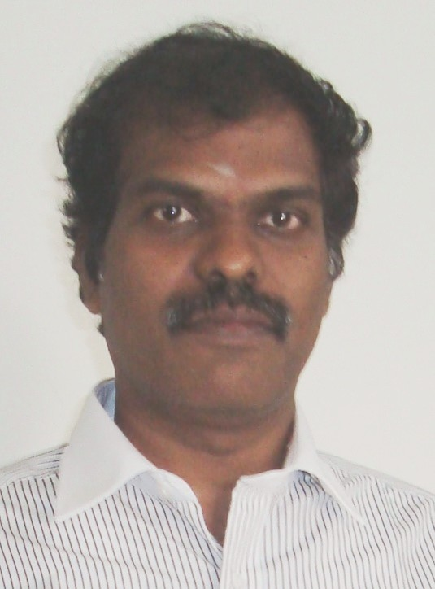

**M.Tech (Energy Engineering)**

[Email:***maheshenergy@gmail.com***](mailto:chozanrajasekaran@gmail.com)

Mobile No**:*+91-9444269832***

# Educational Qualification

|  |  |  |  |  |
| --- | --- | --- | --- | --- |
| **Degree** | **Specialization** | **University** | **Year of Passing** | **Percentage / CGPA** |
| M.Tech | Energy Engineering | Bharathidasan  University | 2002 | 8.7 CGPA |
| B.E | Mechanical Engineering | Madurai Kamaraj University | 1997 | 67% |

***Teaching and Research Experience***

* As Associate Professor from 02-06-2010 to 28-4-2017 at KCG College of Technology, Chennai
* As Senior Lecturer from 05-01-2010 to 25-05-2010 at Velammal Engineering College, Chennai
* As Senior Lecturer from 02-06-2003 to 30-12-2009 at Kumaraguru College of Technology, Coimbatore

# Subjects taught

* Renewable Energy Systems
* Energy Conservation and Management
* Bio Energy
* Solar Energy
* Thermal Engineering
* Heat and Mass Transfer
* Automobile Engineering
* Power Plant Engineering

# Industrial Experience

* Energy Engineer from 01-02-2002 to 15-05-2003at Elpro Energy Dimensions (P) Ltd., Bangalore
* CADD Engineer from 01-05-1998 to 30-04-2000 at Hitech CADD Designers, Chennai
* CADD Engineer from 01-09-1997 to 03-03-1998 CADD Center, Tiruchirappalli.

***Professional Certification***

* *Bureaue of Energy Efficiency(BEE),Government of India, Certified Energy Auditor*

# Autodesk Certified Auto CAD Engineer

# Area of Expertise

Energy Auditing of Buildings,Energy Audit Report Preparation.

***Patents***

1.Title: Fridge with food heater

Application No: 3464/CHE/2014 A

Date of Publication:12/09/2014

2.Title: Stirling electric Chula

Application No: 201641006215

Date of Application:23/2/2016

# Honour and Awards

1. Mentor award for best National project by IEEMA in 2016
2. Best faculty award by KCG College of Technology in 2015
3. Mentor award for best student projects by Institution of Engineers India (IEI)
4. Best project award by Tamil Nadu State Council for Science and Technology (TNSCST)

# Paper Publication

National Journal – 3

International & National Conferences -6

Workshop & Training Programs Attended -8

Project Proposals Submitted -2

Conference,Workshops,Seminars & Program Conducted -8

# Membership

* Life Member IAENG International Associations Engineers
* Member of Solar energy Society of India (SESI)
* Member in Society of Automotive Engineers (SAE)
* Life Member in Indian Society of Technical Education (ISTE)

# Personal Profile

Father’s Name :K.Govindaraju

Date of birth :15.09.1974

Sex :Male

Nationality & Religion :Indian –Hindu

Present address : 8/3, Thulukkanathamman Koil Street, Kottur,

Chennai-85

***Declaration:***

Herewith I have declared that the information furnished above are true and correct to the best of my knowledge and belief.

Place: Chennai

Date:20.11.2020 (K.G. MAHESWARAN )